Zhiwei qiu 143304186

october 06/19  zqiu12@myseneca.ca

**(WEB322) -Web Programming Tools and Frameworks ASSIGNMENT 1**

Table of Contents

**Table of contents1**

**App.js2**

**CSS3**

**main.handlebars 16**

**home.handlebars 22**

**room.handlebars 24**

**sign.handlebars 26**

**Screenshots(Homepage)28**

**Roomlist29**

**Sign up page30**

**App.js**

const express = require("express");

const exphbs = require('express-handlebars');

const app = express();

app.use(express.static('public'));

app.engine('handlebars', exphbs());

app.set('view engine', 'handlebars');

app.get("/", (req, res) => {

    res.render("home")

});

app.get("/room", (req, res) => {

    res.render("room")

});

app.get("/sign", (req, res) => {

    res.render("sign")

});

app.listen(3000);

**CSS**

/* template*/

header{

    font-family: Circular, -apple-system, BlinkMacSystemFont, Roboto, Helvetica Neue, sans-serif;

font-size: 14px;

line-height: 1.43;

color: #484848;

padding-top:1rem;

}

body

{

background-image: url("https://a0.muscache.com/4ea/air/r:w3100-h2074-sfit,e:fjpg-c80/pictures/0ffd8594-f123-43f0-85bb-7ef88c6f0624.jpg");

background-repeat:no-repeat;

background-size: cover;

}

svg{

    height: 1em;

width: 1em;

display:inline-block;

color:white;

}

#logo{

    display: inline-block   ;

vertical-align: middle   ;

font-size: 34px   ;

transition: color 0.25s ease 0s   ;

color: rgb(255, 255, 255)   ;

padding-left:1rem;

}

#head1

{

    display: grid;

    grid-template-columns: 9.8fr .2fr;

}

.nav

{

    display: inline-block   ;

    padding: 1rem   ;

    vertical-align: middle   ;

line-height: 3   ;

border-bottom: 2px solid transparent   ;

color:white;

font-size: inherit;

font-family: inherit;

}

#box1

{

    height: 100%   ;

vertical-align: middle   ;

box-sizing: border-box   ;

border-bottom: 2px solid transparent   ;

width:9.5rem;

}

#box2

{

    height: 100%   ;

vertical-align: middle   ;

box-sizing: border-box   ;

border-bottom: 2px solid transparent   ;

width:10rem;

}

#box3

{

    height: 100%   ;

vertical-align: middle   ;

box-sizing: border-box   ;

border-bottom: 2px solid transparent   ;

width:5rem;

}

ul

{

    list-style-type: none;

    margin: 0;

  padding: 0;

}

.nav:hover{

    border-bottom: .1rem solid white  ;

}

#nav_grid

{

    display: grid;

    grid-template-columns: 1fr 1fr 1fr 1fr 1fr;

}

.footer1{

    margin: 0px   ;

overflow-wrap: break-word   ;

font-family: Circular, -apple-system, BlinkMacSystemFont, Roboto, Helvetica Neue, sans-serif   ;

font-size: 14px   ;

font-weight: 800   ;

line-height: 1.28571em   ;

color: rgb(72, 72, 72)   ;

}

a{

    text-decoration:none;

}

footer{

    padding-top:8rem;

}

footer a{

    color:white;

}

#footer_grid

{

    display:grid;

    grid-template-columns:1fr 1fr 1fr 1fr;

    grid-column-gap: 8rem;

}

.footer_media

{

    display: inline-block   ;

padding-left: 8px   ;

padding-right: 8px   ;

vertical-align: middle   ;

}

footer svg{

    height: 18px;

width: 18px;

display: inline-block;

fill:blue;

}

.footer_link

{

    cursor: pointer   ;

background-color: transparent   ;

color: blue   ;

border: 0px none   ;

display: inline  ;

padding: 0px; margin: 0px;

}

#footer_logo

{

    padding-left: 5rem;

    padding-top:3rem;

}

#footer_list_logos

{

    display: inline-block   ;

margin-left: -5px   ;

white-space: nowrap   ;

vertical-align: middle   ;

}

#footer_terms

{

    margin-bottom: 4px   ;

margin-top: 16px   ;

}

.footer_privacy

{

    margin-bottom: 4px   ;

    color:white;

}

#footer_main

{

    padding: 15px   ;

    max-width: 1080px   ;

    margin: 0px auto   ;

position: relative   ;

background-color:transparent;

}

#footer_bottom

{

    margin: 0px   ;

overflow-wrap: break-word   ;

font-family: Circular, -apple-system, BlinkMacSystemFont, Roboto, Helvetica Neue, sans-serif   ;

font-size: 14px   ;

font-weight: 600   ;

line-height: 1.28571em   ;

color: rgb(118, 118, 118)   ;

padding-left:0.1rem;

}

#footer_bottom2

{

    display: inline-flex;

    padding:0;

}

#footer_bottom3

{

    display: grid;

    grid-template-columns:.1fr 9.9fr;

    padding:0;

}

#footer_svg_bottom

{

    padding-left:2rem;

}

/*home page*/

#home

{

    margin: 0px auto   ;

position: relative   ;

max-width: 1760px   ;

padding-right: 80px   ;

padding-left: 0px   ;

}

#home1

{

    background: rgb(255, 255, 255) none repeat scroll 0% 0%   ;

    border-radius: 4px   ;

    padding: 32px 32px 24px   ;

    width: 441px   ;

    box-shadow: rgba(0, 0, 0, 0.12) 0px 16px 40px   ;

}

.home2

{

    font-size: 1rem   ;

line-height: 36px   ;

letter-spacing: normal   ;

font-family: Circular, -apple-system, BlinkMacSystemFont, Roboto, Helvetica Neue, sans-serif   ;

color: rgb(72, 72, 72)   ;

margin: 0px   ;

padding: 0px   ;

}

.home_labels

{

    margin: 0px   ;

overflow-wrap: break-word   ;

font-family: Circular, -apple-system, BlinkMacSystemFont, Roboto, Helvetica Neue, sans-serif   ;

font-size: 12px   ;

font-weight: 800   ;

line-height: 1.33333em   ;

letter-spacing: 0.0833333em   ;

color: rgb(72, 72, 72)   ;

padding-bottom: 1rem;

}

.home_whereIP

{

    -moz-box-align: center   ;

    padding-left: 12px   ;

    padding-right: 12px   ;

    position: relative   ;

    align-items: center   ;

    background-color: rgb(255, 255, 255)   ;

    display: flex   ;

    height: 48px   ;

    width: 100%   ;

    border:1px solid sliver;

    font-size: 17px   ;

background-color: transparent   ;

margin: 0px   ;

padding: 0px   ;

width: 100%   ;

text-overflow: ellipsis   ;

}

.home_date

{

    font-size: var(--font-form-element-font-size, 17px)   ;

line-height: var(--font-form-element-line-height, 24px)   ;

letter-spacing: var(--font-form-element-letter-spacing, normal)   ;

text-transform: var(--font-form-element-text-transform, undefined)   ;

color: var(--font-form-element-color, #484848)   ;

padding-top: var(--spacing-form-element-vertical, 11px)   ;

padding-bottom: var(--spacing-form-element-vertical, 11px)   ;

font-weight: var(--font-light-font-weight, normal)   ;

background-color: var(--color-clear, transparent)   ;

padding-left: var(--spacing-form-element-horizontal, 0px)   ;

padding-right: var(--spacing-form-element-horizontal, 11px)   ;

border:0px none;

}

#home_grid

{

    display: grid;

    grid-template-columns: 1fr 1fr;

    padding-top: 2rem;

}

#home_guest

{

    background: rgba(0, 0, 0, 0) none repeat scroll 0% 0%   ;

position: relative   ;

text-align: left   ;

border: 1px solid rgb(235, 235, 235)   ;

border-radius: 3px   ;

padding: 8px 11px 11px   ;

font-size: 16px   ;

font-weight: 400   ;

line-height: normal   ;

display: block   ;

width: 100%   ;

height: 48px   ;

color: rgb(118, 118, 118)   ;

}

#home_svg

{

    position: absolute   ;

right: 11px   ;

top: 0px   ;

bottom: 0px   ;

margin: auto   ;

pointer-events: none   ;

display: block   ;

height: 12px   ;

width: 12px   ;

}

#home1{

color:white;

}

#home_promo

{

    font-size: 2rem;

    height:15rem;

    margin-top:1rem;

    text-align: center;

    padding-top: 5rem;

}

#home_promo2

{

    background-image: url(promo.png);

    background-repeat: no-repeat;

    z-index: -1;

    height: 10rem;

    margin-top: 3rem;

}

.home_promo3

{

    font-size: 32px;

font-weight: normal;

color:white;

text-align: center;

}

#home_invitebox

{

    background-color: white;

    width:8rem;

    height: 3rem;

    text-align: center;

    margin-left:40rem;

    margin-top:1rem;

    font-family: Circular, -apple-system, BlinkMacSystemFont, Roboto, Helvetica Neue, sans-serif;

    font-size: 14px;

    line-height: 1.43;

}

#home_aboutus{

    width:auto;

    background-image: url(/aboutus.jpg);

    background-repeat: no-repeat;

    background-size: cover;

    opacity: 0.6;

    width:80%;

    height: 19.55rem;

}

#home_aboutus_grid

{

    display: grid;

    grid-template-columns: 1fr 4fr;

    padding-top: 1rem;

}

#home_aboutus_label

{

    font-size: 32px;

    line-height: 1.375;

    font-weight: 600;

    color:white;

    padding-left: 1rem;

}

#home_aboutus_p

{

    font-size: 1rem;

    line-height: 1.66667;

    text-rendering: optimizeLegibility;

    color:white;

    font-family: Cereal,sans-serif;

    padding-left: 1rem;

}

/* room */

#room_main

{

    background-color: white;

}

#room_h2

{

    font-size: 2.5rem;

    color: #363636;

    font-family: "Josefin Sans", sans-serif;

font-weight: 600;

line-height: 1.125;

text-align: center;

}

.room_grid

{

    display: grid;

    grid-template-columns: 1fr 1fr 1fr;

    padding: 1rem;

    grid-column-gap: 1rem;

}

.room_des1

{

    color: rgb(34, 34, 34)   ;

font-family: Circular, -apple-system, BlinkMacSystemFont, Roboto, Helvetica Neue, sans-serif   ;

font-weight: 400   ;

font-size: 18px   ;

line-height: 24px   ;

max-height: 24px   ;

overflow: hidden   ;

text-overflow: ellipsis   ;

display: -webkit-box   ;

-webkit-line-clamp: 1   ;

-moz-box-orient: vertical   ;

margin-top:12px;

}

.room_des2

{

    color: rgb(34, 34, 34)   ;

    font-family: Circular, -apple-system, BlinkMacSystemFont, Roboto, Helvetica Neue, sans-serif   ;

    font-weight: 400   ;

    font-size: 18px   ;

    line-height: 24px   ;

    max-height: 24px   ;

    overflow: hidden   ;

    text-overflow: ellipsis   ;

    display: -webkit-box   ;

    -webkit-line-clamp: 1   ;

    -moz-box-orient: vertical   ;

}

.room_des3

{

    -moz-box-align: center   ;

    align-items: center   ;

    color: rgb(34, 34, 34)   ;

    display: flex   ;

    font-family: Circular, -apple-system, BlinkMacSystemFont, Roboto, Helvetica Neue, sans-serif   ;

    font-weight: 400   ;

    font-size: 18px   ;

    line-height: 24px   ;

    margin-top:12px;

}

.room_img_box

{

    padding: .75rem;

    border:1px solid grey;

}

.room_img_boxinner

{

    border-radius: 6px;

display: block;

padding: 1.25rem;

}

.room_img

{

    height: auto;

    width:100%;

    display: block;

}

.room_price

{

    font-weight:bold;

}

/* sign up */

#signup_grid

{

    display: grid;

    grid-template-columns: 1.5fr 2fr 1.5fr;

}

.signup_box1

{

    display: hidden;

}

#signup_box2

{

    background-color: white;

}

#signup_or

{

    padding-top:.5rem;

    padding-bottom: .5rem;

    color:black;

    font-size: 1.5rem;

    text-align: center;

    line-height: 3rem;

    font-family: "Josefin Sans", sans-serif;

}

.signup_label

{

    margin: 0px  ;

    overflow-wrap: break-word   ;

    font-family: Circular, -apple-system, BlinkMacSystemFont, Roboto, Helvetica Neue, sans-serif   ;

    font-size: 1rem   ;

    font-weight: 800   ;

    line-height: 1.33333em   ;

    letter-spacing: 0.0833333em   ;

    color: rgb(72, 72, 72)   ;

    padding-left:.5rem;

}

.signup_input

{

    -moz-box-align: center   ;

    position: relative   ;

    align-items: center   ;

    background-color: rgb(255, 255, 255)   ;

    display: flex   ;

    height: 30px   ;

    font-size: 20px   ;

border: 1px solid sliver;

border-radius: 5px;

margin: 0px   ;

padding: 0px   ;

width: 100%   ;

text-overflow: ellipsis   ;

}

.signup_input2

{

    padding: 1rem .5rem 2rem .5rem;

}

#signup_submit

{

    background-color: rgb(151, 101, 103);

border-color: transparent;

color: #fff;

justify-content: center;

padding-bottom: calc(.375em - 1px);

padding-left: .5em;

padding-right: .75em;

padding-top: calc(.375em - 1px);

text-align: center;

white-space: nowrap;

font-size:2rem;

}

#signup_submit_box

{

    display: flex;

 justify-content: flex-end;

}

#signup_link

{

    text-decoration: none;

}

#signup_option

{

border-color: transparent;

color: black;

justify-content: center;

padding-bottom: calc(.375em - 1px);

padding-left: .5em;

padding-right: .75em;

padding-top: 2rem;

text-align: center;

white-space: nowrap;

    font-size:2rem;

    font-family: Circular, -apple-system, BlinkMacSystemFont, Roboto, Helvetica Neue, sans-serif

}

/*all*/

**Main.handlebars**

<html>

<head>

    <meta charset="utf-8">

    <title>Airbnb</title>

    <link rel="stylesheet" href="1.css">

    <link rel="stylesheet" href="popupS.css">

</head>

<body>

 <header id="head1">

 <div id="head1">

     <div id="logo">

         <a href="/"><svg viewBox="0 0 1000 1000" role="presentation" aria-hidden="true" focusable="false" style="height:1em;width:1em;display:block;fill:currentColor"><path d="m499.3 736.7c-51-64-81-120.1-91-168.1-10-39-6-70 11-93 18-27 45-40 80-40s62 13 80 40c17 23 21 54 11 93-11 49-41 105-91 168.1zm362.2 43c-7 47-39 86-83 105-85 37-169.1-22-241.1-102 119.1-149.1 141.1-265.1 90-340.2-30-43-73-64-128.1-64-111 0-172.1 94-148.1 203.1 14 59 51 126.1 110 201.1-37 41-72 70-103 88-24 13-47 21-69 23-101 15-180.1-83-144.1-184.1 5-13 15-37 32-74l1-2c55-120.1 122.1-256.1 199.1-407.2l2-5 22-42c17-31 24-45 51-62 13-8 29-12 47-12 36 0 64 21 76 38 6 9 13 21 22 36l21 41 3 6c77 151.1 144.1 287.1 199.1 407.2l1 1 20 46 12 29c9.2 23.1 11.2 46.1 8.2 70.1zm46-90.1c-7-22-19-48-34-79v-1c-71-151.1-137.1-287.1-200.1-409.2l-4-6c-45-92-77-147.1-170.1-147.1-92 0-131.1 64-171.1 147.1l-3 6c-63 122.1-129.1 258.1-200.1 409.2v2l-21 46c-8 19-12 29-13 32-51 140.1 54 263.1 181.1 263.1 1 0 5 0 10-1h14c66-8 134.1-50 203.1-125.1 69 75 137.1 117.1 203.1 125.1h14c5 1 9 1 10 1 127.1.1 232.1-123 181.1-263.1z"></path>

         </svg>

         </a>

     </div>

     <div >

         <nav >

         <ul id="nav_grid">

             <li><a href="/room"><div id="box1"><div class="nav">Host a home</div></div></a></li>

              <li><a href="/room"><div id="box2"><div class="nav">Host an experience</div></div></a></li>

               <li><a href="/room"><div id="box3"><div class="nav">Help</div></div></a></li>

                <li><a href="/sign"><div id="box3"><div class="nav">Sign up</div></div></a></li>

                 <li><a href="/sign"><div id="box3"><div class="nav">Log in</div></div></a></li>

         </ul>

    </nav>

    </div>

 </div>

 </header>

    {{{body}}}

 <footer >

     <div id="footer_main">

     <div id="footer_grid">

         <div>

             <h4>

                 <div class="footer1">Airbnb</div>

             </h4>

             <ul>

                 <li class="footer_privacy"><a href="https://careers.airbnb.com/">Careers</a></li>

                 <li class="footer_privacy"><a href="https://press.airbnb.com/">News</a></li>

                 <li class="footer_privacy"><a href="https://www.airbnb.ca/help/topic/250/terms-policies">Policies</a></li>

                 <li class="footer_privacy"><a href="https://www.airbnb.ca/help?from=footer">Help</a></li>

                 <li class="footer_privacy"><a href="https://www.airbnb.ca/diversity">Diversity & Belonging</a></li>

                 <li class="footer_privacy"><a href="://www.airbnb.ca/d/accessibility">Accessibility</a></li>

             </ul>

         </div>

         <div>

             <h4>

                 <div class="footer1">Discover</div>

             </h4>

             <ul>

                 <li class="footer_privacy"><a href="https://www.airbnb.ca/trust">Trust & Safety</a></li>

                 <li class="footer_privacy"><a href="https://www.airbnb.ca/invite?r=6">Travel Credit</a></li>

                 <li class="footer_privacy"><a href="https://www.airbnbcitizen.com/?utm_source=airbnb&utm_medium=footer&utm_campaign=product">Airbnb Citizen</a></li>

                 <li class="footer_privacy"><a href="https://www.airbnb.ca/work?s=footer">Business Travel</a></li>

                 <li class="footer_privacy"><a href="https://www.airbnb.ca/things-to-do">Things To Do</a></li>

                 <li class="footer_privacy"><a href="https://www.airbnb.ca/magazine?locale=en">Airbnbmag</a></li>

             </ul>

         </div>

         <div>

             <h4>

                 <div class="footer1">Hosting</div>

             </h4>

             <ul>

                 <li class="footer_privacy"><a href="https://www.airbnb.ca/host/homes?from_footer=1">Why Host</a></li>

                 <li class="footer_privacy"><a href="https://www.airbnb.ca/hospitality">Hospitality</a></li>

                 <li class="footer_privacy"><a href="https://www.airbnb.ca/hospitality">Responsible Hosting</a></li>

                 <li class="footer_privacy"><a href="https://community.withairbnb.com/t5/Community-Center/ct-p/community-center">Community Centre</a></li>

                 <li class="footer_privacy"><a href="https://www.airbnb.ca/host/experiences?from_footer=1">Host an Experience</a></li>

                 <li class="footer_privacy"><a href="https://www.airbnb.ca/openhomes?from_footer=1">Open Homes</a></li>

             </ul>

         </div>

         <div id="footer_logo">

             <ul>

                 <li id="footer_list_logos">

                     <span class="footer_media">

                         <a  class="footer_link" href="https://www.facebook.com/airbnb">

                             <svg viewBox="0 0 32 32" role="img" aria-label="Navigate to Facebook" focusable="false" style="height: 18px; width: 18px; display: block; fill: rgb(118, 118, 118);"><path d="m8 14.41v-4.17c0-.42.35-.81.77-.81h2.52v-2.08c0-4.84 2.48-7.31 7.42-7.35 1.65 0 3.22.21 4.69.64.46.14.63.42.6.88l-.56 4.06c-.04.18-.14.35-.32.53-.21.11-.42.18-.63.14-.88-.25-1.78-.35-2.8-.35-1.4 0-1.61.28-1.61 1.73v1.8h4.52c.42 0 .81.42.81.88l-.35 4.17c0 .42-.35.71-.77.71h-4.21v16c0 .42-.35.81-.77.81h-5.21c-.42 0-.8-.39-.8-.81v-16h-2.52a.78.78 0 0 1 -.78-.78" fill-rule="evenodd"></path>

                             </svg>

                         </a>

                     </span>

                     <span class="footer_media">

                         <a class="footer_link" href="https://twitter.com/airbnb">

                             <svg viewBox="0 0 32 32" role="img" aria-label="Navigate to Twitter" focusable="false" style="height: 18px; width: 18px; display: block; fill: rgb(118, 118, 118);"><path d="m31 6.36c-1.16.49-2.32.82-3.55.95 1.29-.76 2.22-1.87 2.72-3.38a13.05 13.05 0 0 1 -3.91 1.51c-1.23-1.28-2.75-1.94-4.51-1.94-3.41 0-6.17 2.73-6.17 6.12 0 .49.07.95.17 1.38-4.94-.23-9.51-2.6-12.66-6.38-.56.95-.86 1.97-.86 3.09 0 2.07 1.03 3.91 2.75 5.06-1-.03-1.92-.3-2.82-.76v.07c0 2.89 2.12 5.42 4.94 5.98-.63.17-1.16.23-1.62.23-.3 0-.7-.03-1.13-.13a6.07 6.07 0 0 0 5.74 4.24c-2.22 1.74-4.78 2.63-7.66 2.63-.56 0-1.06-.03-1.43-.1 2.85 1.84 6 2.76 9.41 2.76 7.29 0 12.83-4.01 15.51-9.3 1.36-2.66 2.02-5.36 2.02-8.09v-.46c-.03-.17-.03-.3-.03-.33a12.66 12.66 0 0 0 3.09-3.16" fill-rule="evenodd"></path>

                             </svg>

                         </a>

                     </span>

                     <span class="footer_media">

                         <a class="footer_link" href="https//www.instagram.com/airbnb/">

                             <svg viewBox="0 0 24 24" role="img" aria-label="Navigate to Instagram" focusable="false" style="height: 18px; width: 18px; display: block; fill: rgb(118, 118, 118);"><path d="m23.09.91c-.61-.61-1.33-.91-2.17-.91h-17.84c-.85 0-1.57.3-2.17.91s-.91 1.33-.91 2.17v17.84c0 .85.3 1.57.91 2.17s1.33.91 2.17.91h17.84c.85 0 1.57-.3 2.17-.91s.91-1.33.91-2.17v-17.84c0-.85-.3-1.57-.91-2.17zm-14.48 7.74c.94-.91 2.08-1.37 3.4-1.37 1.33 0 2.47.46 3.41 1.37s1.41 2.01 1.41 3.3-.47 2.39-1.41 3.3-2.08 1.37-3.41 1.37c-1.32 0-2.46-.46-3.4-1.37s-1.41-2.01-1.41-3.3.47-2.39 1.41-3.3zm12.66 11.63c0 .27-.09.5-.28.68a.92.92 0 0 1 -.67.28h-16.7a.93.93 0 0 1 -.68-.28.92.92 0 0 1 -.27-.68v-10.13h2.2a6.74 6.74 0 0 0 -.31 2.05c0 2 .73 3.71 2.19 5.12s3.21 2.12 5.27 2.12a7.5 7.5 0 0 0 3.75-.97 7.29 7.29 0 0 0 2.72-2.63 6.93 6.93 0 0 0 1-3.63c0-.71-.11-1.39-.31-2.05h2.11v10.12zm0-13.95c0 .3-.11.56-.31.77a1.05 1.05 0 0 1 -.77.31h-2.72c-.3 0-.56-.11-.77-.31a1.05 1.05 0 0 1 -.31-.77v-2.58c0-.29.11-.54.31-.76s.47-.32.77-.32h2.72c.3 0 .56.11.77.32s.31.47.31.76z" fill-rule="evenodd"></path>

                             </svg>

                         </a>

                     </span>

                 </li>

                 <li id="footer_terms"><a href="https://www.airbnb.ca/terms">Terms</a></li>

                 <li class="footer_privacy"><a href="https://www.airbnb.ca/terms/privacy_policy">Privacy</a></li>

                 <li class="footer_privacy"><a href="https://www.airbnb.ca/sitemaps/v2">Site Map</a></li>

             </ul>

         </div>

     </div>

     </div>

         <div id="footer_bottom3">

             <svg  id="footer_svg_bottom"viewBox="0 0 1000 1000" role="presentation" aria-hidden="true" focusable="false" style="height: 1.5em; width: 1.5em; display: block; fill: rgb(118, 118, 118);"><path d="m499.3 736.7c-51-64-81-120.1-91-168.1-10-39-6-70 11-93 18-27 45-40 80-40s62 13 80 40c17 23 21 54 11 93-11 49-41 105-91 168.1zm362.2 43c-7 47-39 86-83 105-85 37-169.1-22-241.1-102 119.1-149.1 141.1-265.1 90-340.2-30-43-73-64-128.1-64-111 0-172.1 94-148.1 203.1 14 59 51 126.1 110 201.1-37 41-72 70-103 88-24 13-47 21-69 23-101 15-180.1-83-144.1-184.1 5-13 15-37 32-74l1-2c55-120.1 122.1-256.1 199.1-407.2l2-5 22-42c17-31 24-45 51-62 13-8 29-12 47-12 36 0 64 21 76 38 6 9 13 21 22 36l21 41 3 6c77 151.1 144.1 287.1 199.1 407.2l1 1 20 46 12 29c9.2 23.1 11.2 46.1 8.2 70.1zm46-90.1c-7-22-19-48-34-79v-1c-71-151.1-137.1-287.1-200.1-409.2l-4-6c-45-92-77-147.1-170.1-147.1-92 0-131.1 64-171.1 147.1l-3 6c-63 122.1-129.1 258.1-200.1 409.2v2l-21 46c-8 19-12 29-13 32-51 140.1 54 263.1 181.1 263.1 1 0 5 0 10-1h14c66-8 134.1-50 203.1-125.1 69 75 137.1 117.1 203.1 125.1h14c5 1 9 1 10 1 127.1.1 232.1-123 181.1-263.1z"></path>

         </svg>

         <span id="footer_bottom">© 2019 Airbnb, Inc. All rights reserved.</span>

        </div>

 </footer>

</body>

</html>

**Home.handlebars**

<div id="home">

    <div id="home1">

    <div class="home2">

        <h1>

            Book unique places to

            <br><a href="https://www.airbnb.ca/sitemaps/v2" style="color:inherit">stay</a>

             and things to do.

        </h1>

    </div>

    <form method="POST">

        <div class="home_labels">

            WHERE

        </div>

            <select class="home_whereIP">

                <option >Anywhere</option>

                <option value="Montreal">Montreal</option>

                <option value="Vancouver">Vancouver</option>

                <option value="Calgary">Calgary</option>

                <option value="Toronto">Toronto</option>

            </select>

        <div id="home_grid">

        <div>

            <div style="margin-bottom: 8px">

                <span class="home_labels">CHECK-IN</span>

            </div>

            <div>

                <input type="text" data-veloute="checkin_input"  placeholder="dd-mm-yyyy" class="home_date">

            </div>

        </div>

        <div>

            <div style="margin-bottom: 8px">

                <span class="home_labels">CHECKOUT</span>

            </div>

            <div>

                <input type="text" data-veloute="checkout_input"  placeholder="dd-mm-yyyy" class="home_date">

            </div>

            </div>

        </div>

        <div class="home_labels">

            GUESTS

        </div>

              <input  class="home_whereIP" type="number" name=number placeholder="How many Guests?" min="0" >

    </form>

     </div>

    </div>

<div id="home_promo2">

    <div class="home_promo3">Earn money to use with Airbnb! Get up to $38 CAD for every friend you invite.

    </div>

    <div id="home_invitebox">

        <a style="color:black" href="/sign">Log in to invite friends</a>

    </div>

    <div class="home_promo3">Don't have an account yet? <a href="/sign">Sign up.</a></div>

</div>

<div id="home_aboutus_grid">

    <div><iframe width="560" height="315" src="https://www.youtube.com/embed/-XSAqfK_UwY" frameborder="0" allow="accelerometer; autoplay; encrypted-media; gyroscope; picture-in-picture" allowfullscreen>

    </iframe>

    </div>

    <div id="home_aboutus">

        <label id="home_aboutus_label">About us</label>

    <p id="home_aboutus_p">

        Founded in 2008, Airbnb’s mission is to create a world where people can belong through healthy travel that is local, authentic, diverse, inclusive and sustainable. Airbnb uniquely leverages technology to economically empower millions of people around the world to unlock and monetize their spaces, passions and talents and become hospitality entrepreneurs. Airbnb’s accommodation marketplace provides access to 7 million unique places to stay in more than 100,000 cities and 191 countries and regions. With Experiences, Airbnb offers unprecedented access to local communities and interests through 40,000 unique, handcrafted activities run by hosts across 1,000+ cities around the world. Airbnb’s people-to-people platform benefits all our stakeholders, including hosts, guests, employees and the communities in which we operate.

    </p>

    </div>

</div>

**Room.handlebars**

<div id="room_main">

<h2 id="room_h2">Our Rooms</h2>

<div class="room_grid">

    <div class="room_img_box">

    <div class="room_img_boxinner">

        <img  class="room_img" src="1.jpg" alt:"rooms">

    <div class="room_des1">Entire house · 2 beds</div>

    <div class="room_des2">I SETTE CONI - TRULLO EDERA</div>

    <div class="room_des3"><span class="room_price">Price: $103  CAD</span>/night</div>

    </div>

    </div>

    <div class="room_img_box">

    <div class="room_img_boxinner">

        <img class="room_img" src="2.jpg" alt:"rooms">

    <div class="room_des1">Entire house · 2 beds</div>

    <div class="room_des2">The World Famous Seashell House ~ Casa Caracol</div>

    <div class="room_des3"><span class="room_price">Price: $400  CAD</span>/night</div>

    </div>

    </div>

    <div class="room_img_box">

        <div class="room_img_boxinner">

        <img class="room_img" src="3.jpg" alt:"rooms">

    <div class="room_des1">Hut · 2 beds</div>

    <div class="room_des2">Romantic Cabana with view</div>

    <div class="room_des3"><span class="room_price">Price: $53  CAD</span>/night</div>

    </div>

    </div>

</div>

<div class="room_grid">

    <div class="room_img_box">

    <div class="room_img_boxinner">

        <img  class="room_img" src="4.jpg" alt:"rooms">

    <div class="room_des1">Entire house · 3 beds</div>

    <div class="room_des2">Million dollar view in Cabo!!!</div>

    <div class="room_des3"><span class="room_price">Price: $132  CAD</span>/night</div>

    </div>

    </div>

    <div class="room_img_box">

    <div class="room_img_boxinner">

        <img class="room_img" src="5.jpg" alt:"rooms">

    <div class="room_des1">Entire house · 7 beds</div>

    <div class="room_des2">Villa del Toro Rojo #1 rated Superhost in Pedregal</div>

    <div class="room_des3"><span class="room_price">Price: $666  CAD</span>/night</div>

    </div>

    </div>

    <div class="room_img_box">

        <div class="room_img_boxinner">

        <img class="room_img" src="6.jpg" alt:"rooms">

    <div class="room_des1">Entire house · 1 bed</div>

    <div class="room_des2">Cabo Center,Ocean view Great price!</div>

    <div class="room_des3"><span class="room_price">Price: $39  CAD</span>/night</div>

    </div>

    </div>

</div>

</div>

**Sign.handlebars**

<div id="signup_grid">

    <div class="signup_box1"></div>

    <div id="signup_box2">

        <div id="signup_option">

            Sign up with <a class=" signup_link" href="facebook.com">Facebook</a> or <a class="signup_link" href="google.com">Google</a>

        </div>

    <div id="signup_or">

     or

    </div>

<div>

<form method="POST">

<label class="signup_label">First Name</label>

<div  class="signup_input2">

    <input class="signup_input" type="text" name=firstname placeholder="First Name">

</div>

<label class="signup_label">Last Name</label>

<div  class="signup_input2">

    <input class="signup_input" type="text" name=lastname placeholder="Last Name">

</div>

<label class="signup_label">Email</label>

<div  class="signup_input2">

    <input class="signup_input" type="email" name=email placeholder="Email">

</div>

<label class="signup_label">Password</label>

<div  class="signup_input2">

    <input class="signup_input" type="password" name=password placeholder="Password">

</div>

<label class="signup_label">Birthday</label>

<div  class="signup_input2">

    <input class="signup_input" type="date" name=Birthday placeholder="Birthday">

</div>

 <div id="signup_submit_box">

     <input  id="signup_submit"type="submit" value="Sign up">

 </div>

</form>

</div>

</div>

    <divclass="signup_box1"></div>

</div>

**Screenshot**

**All pages are using same template(main.handlebars), share same headers,footers.**

**Homepage:**

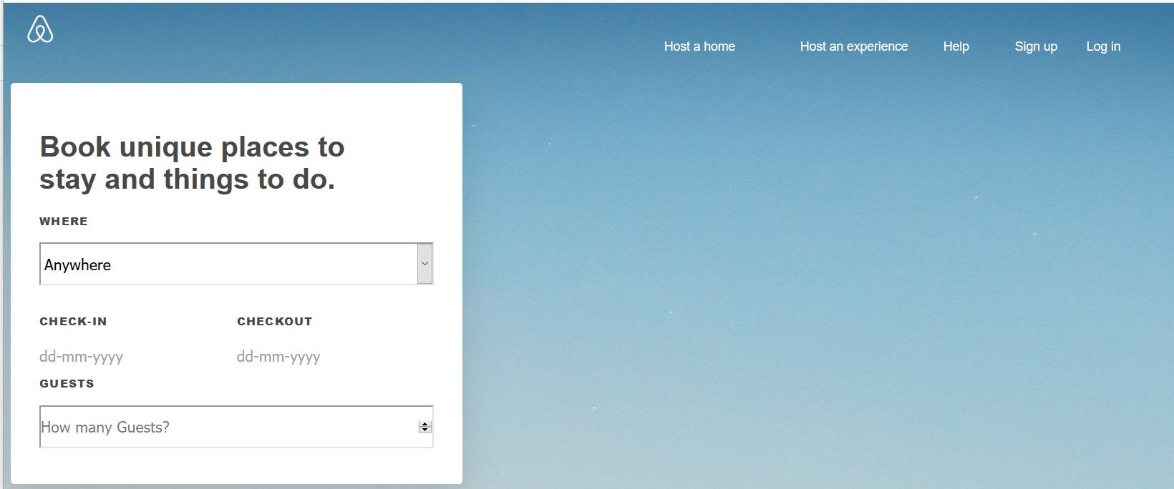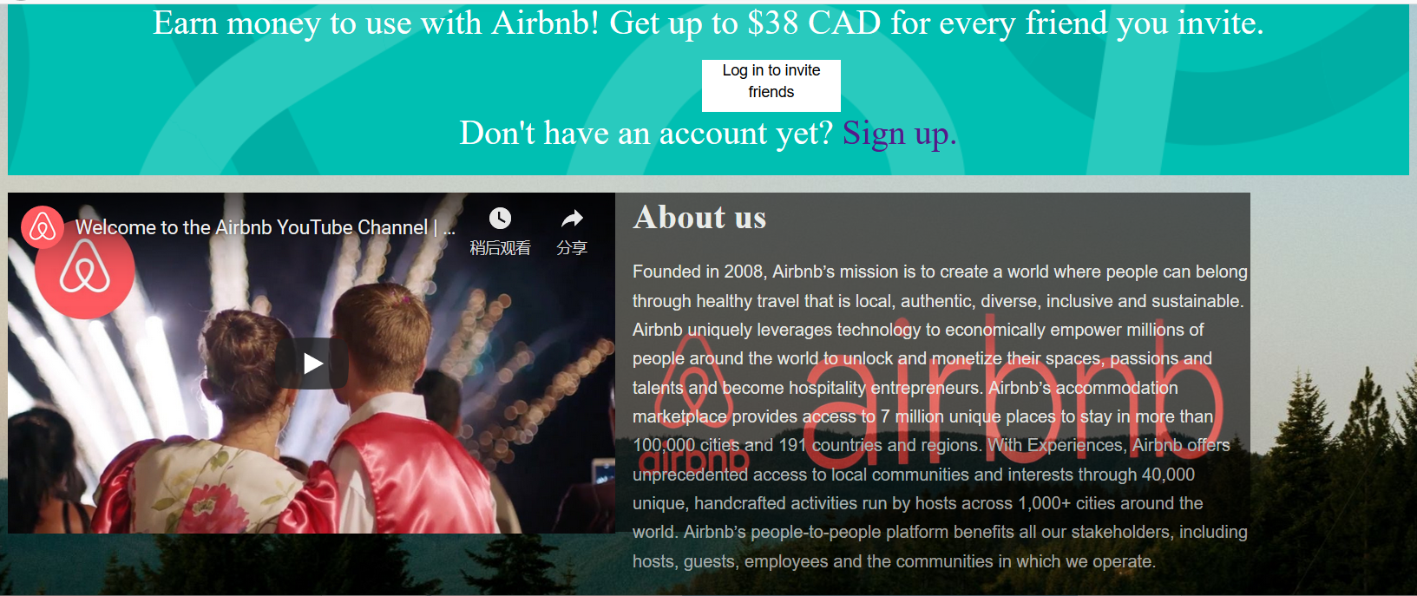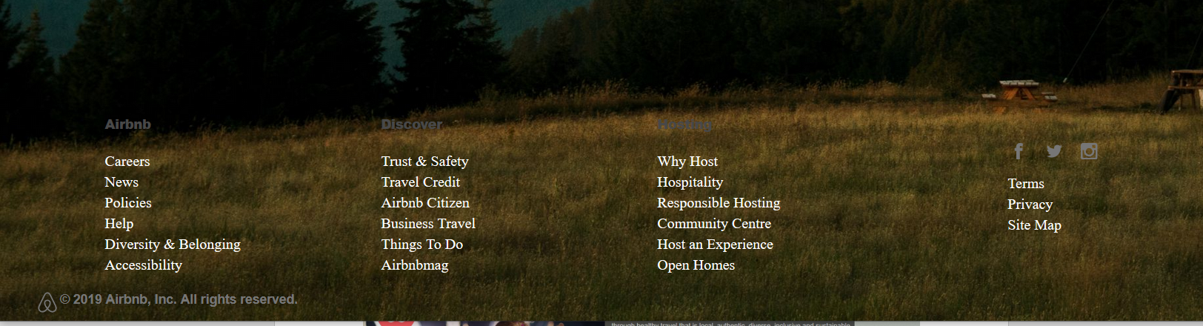

**This page contains a form collect user’s information (a dropdown list contains 4 Canada cities; 2 input boxes for dates, one drops down list for number of guests). One banner for promotion, one video, one picture and one paragraph to introduce Airbnb.**

**Roomslist:**

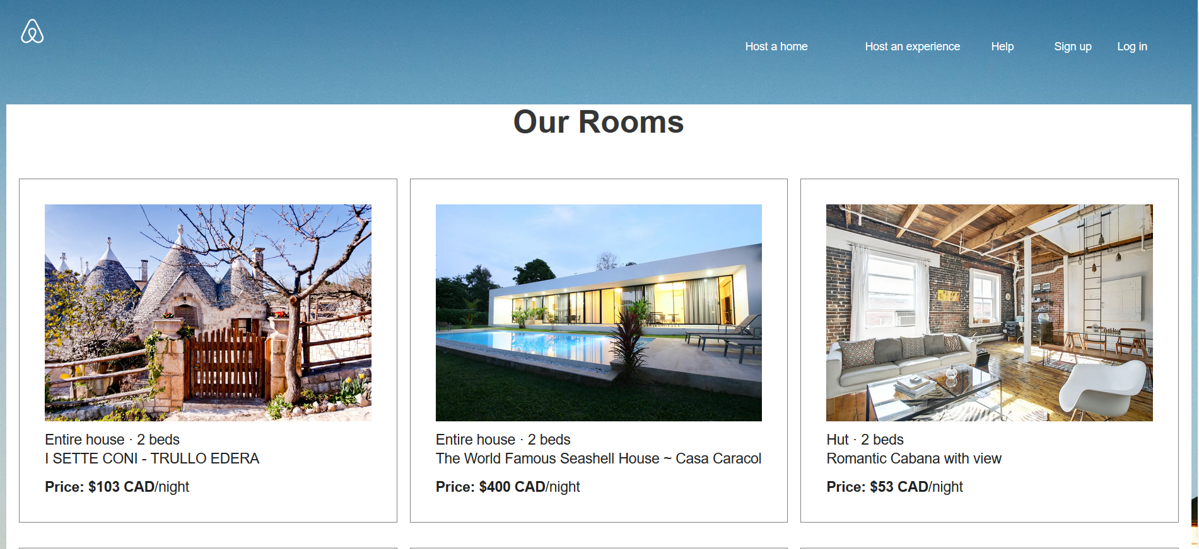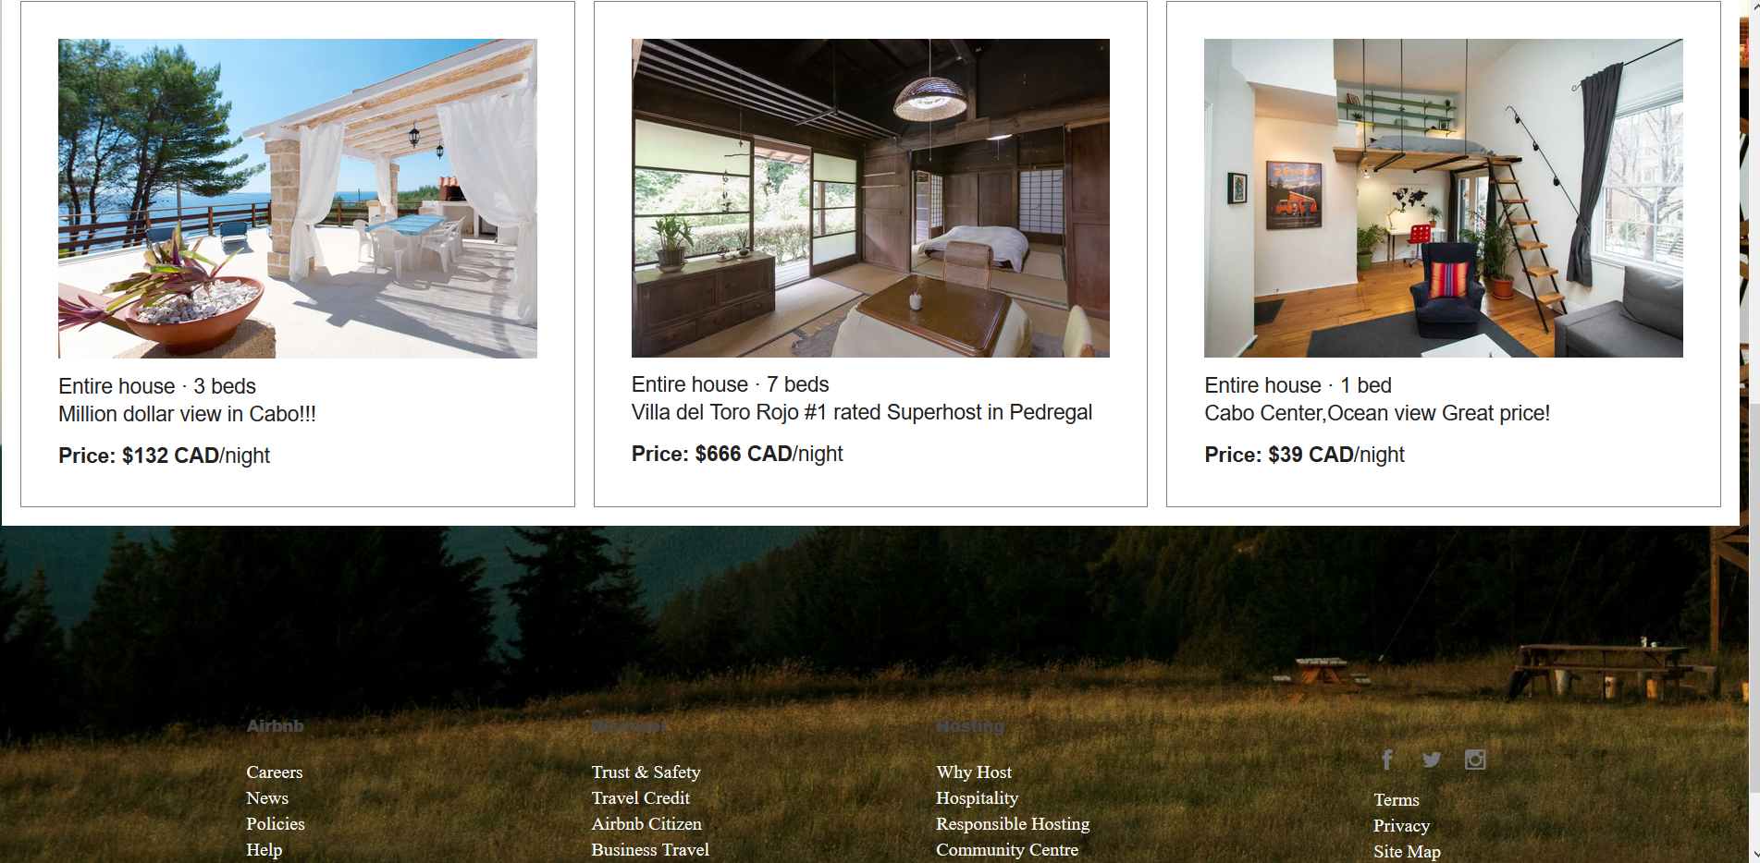

**This page contains a list of 6 rooms include pictures, description of rooms and price.**

**Sign up page:**

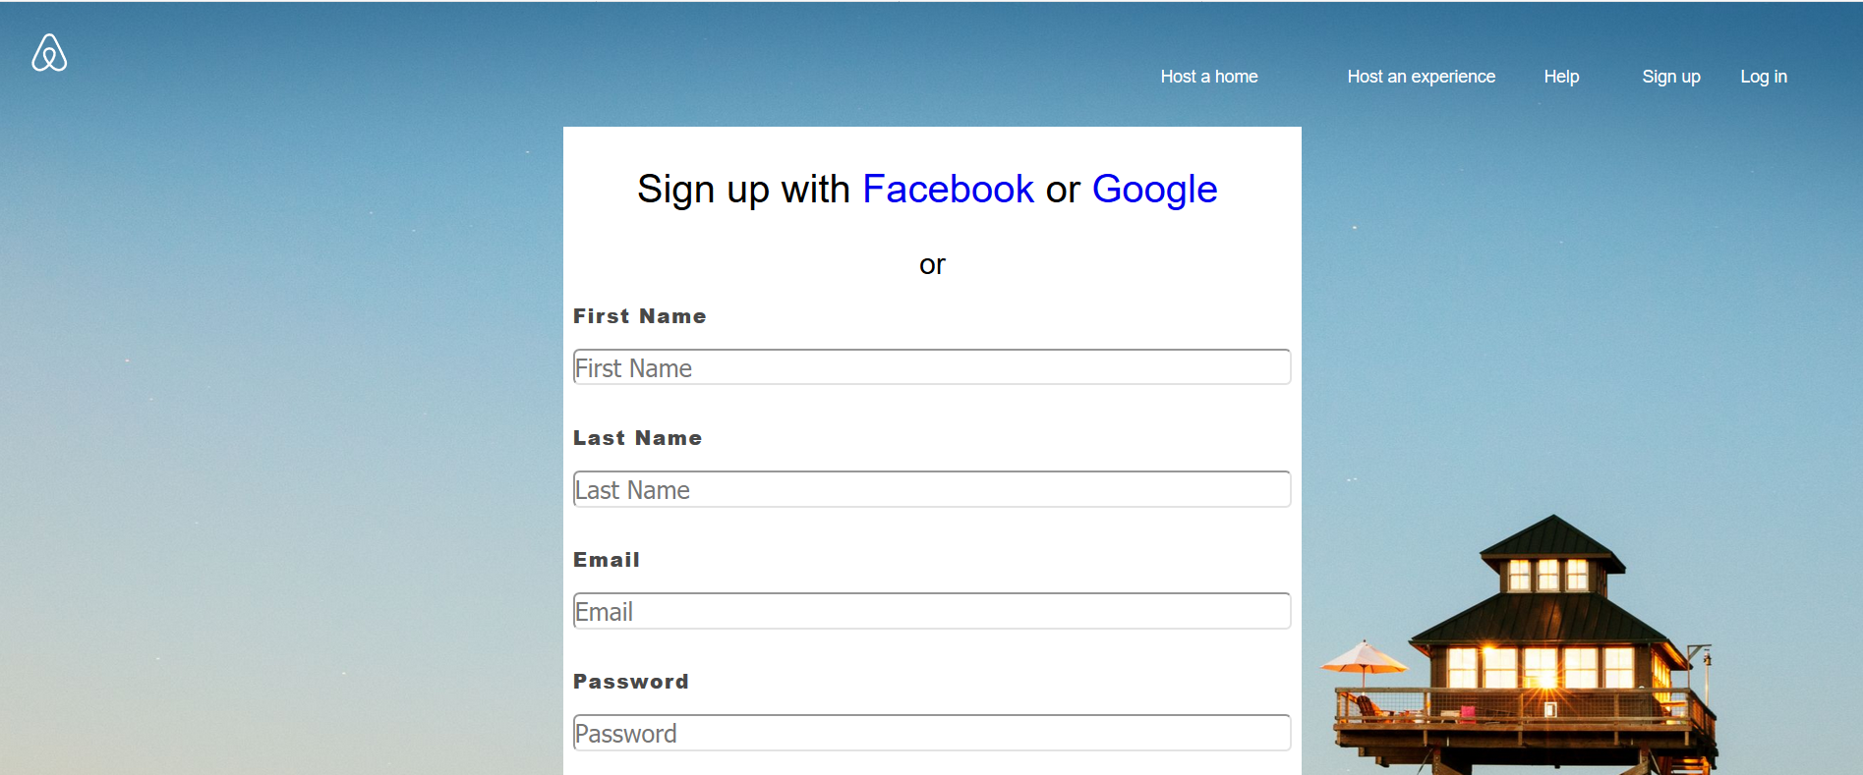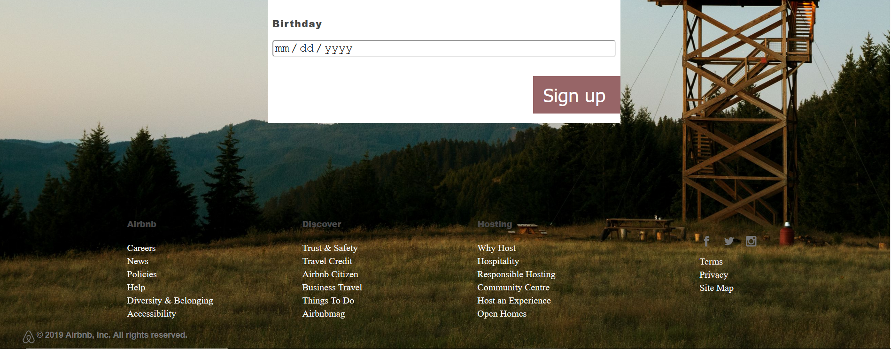

**This page contains a form for user to sign up Airbnb. In this page there are links to Facebook and Google so user can use those accounts to log in. what’s more, a form is provided to user to sign up. it will collects first name, last name, password, birthday as basic information to sign up as a new user.**